CASE STUDY-4

Name of student: Chundru Rishith Sai Chowdary

Registration Number: 12212330

Section: K22BW

1. Display how many sub categories are providing profit and loss to the company

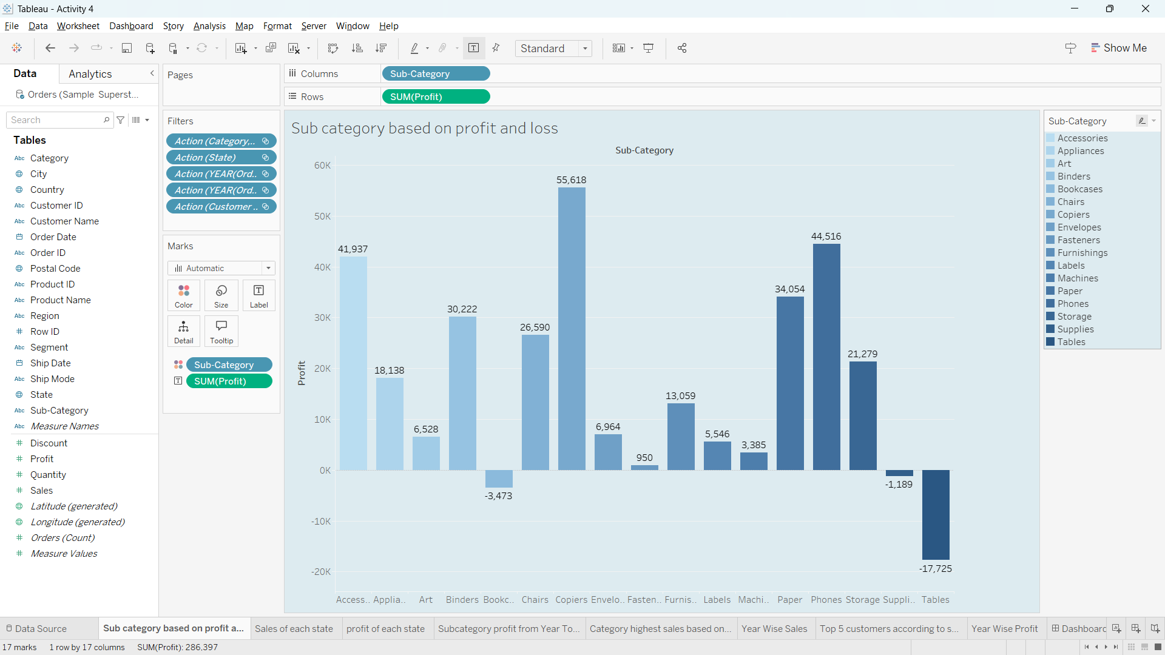

1. Display sales and profit for each state on the tree map.

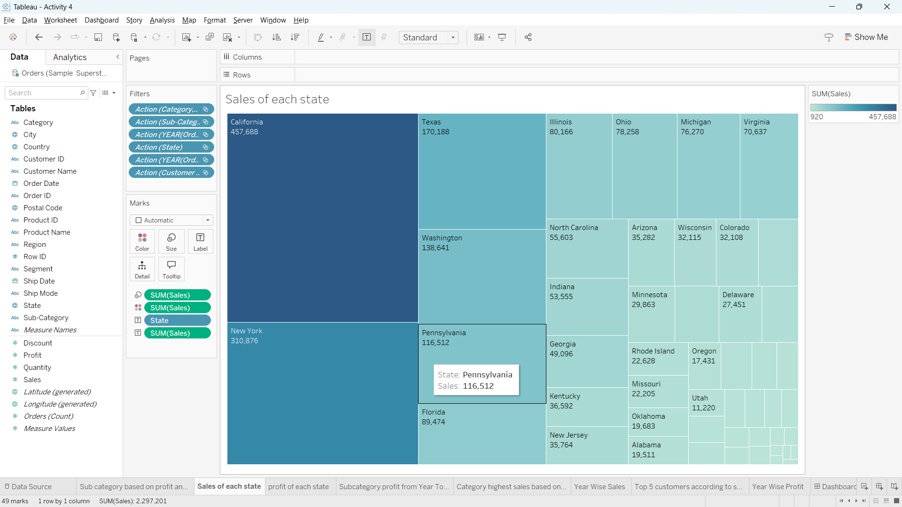

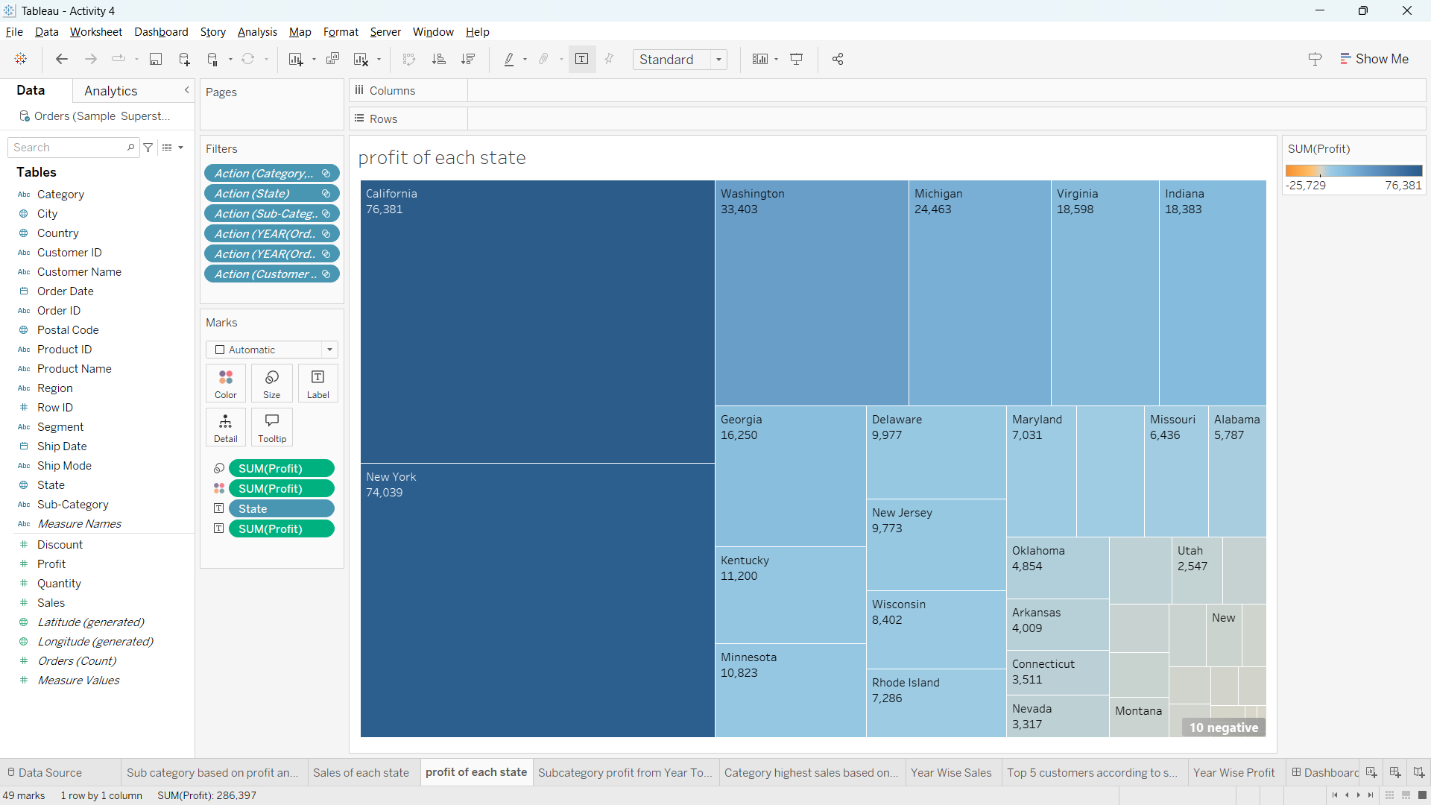

1. Display profit of the company from one sub category to another sub category every year

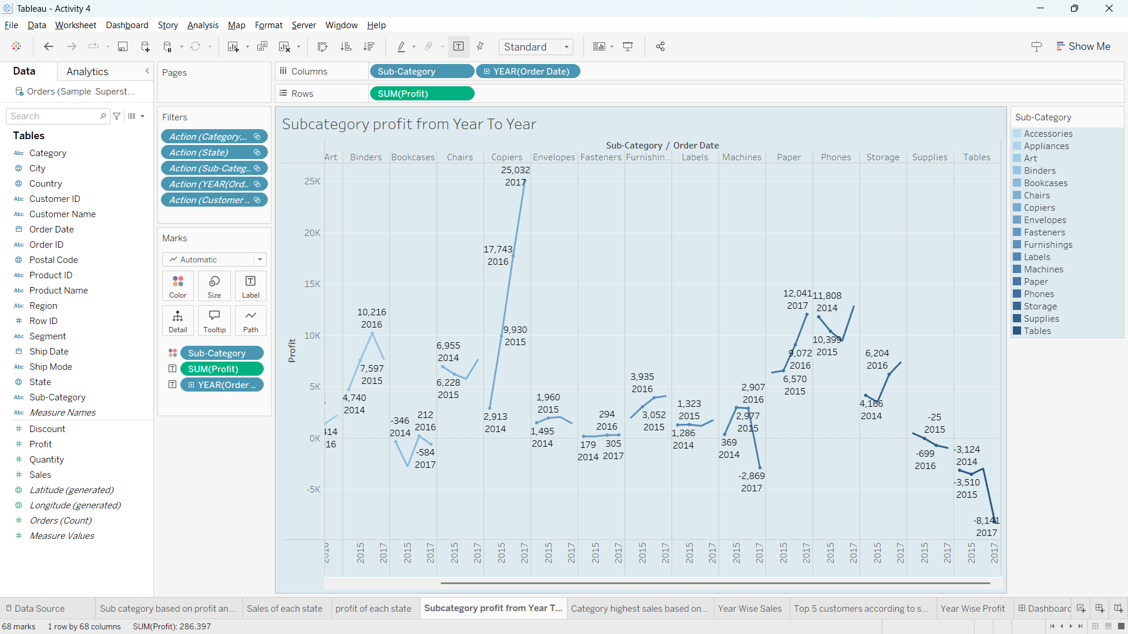

1. What is the percentage of total sales for the ‘ Home office’ customer segment in July 2021?

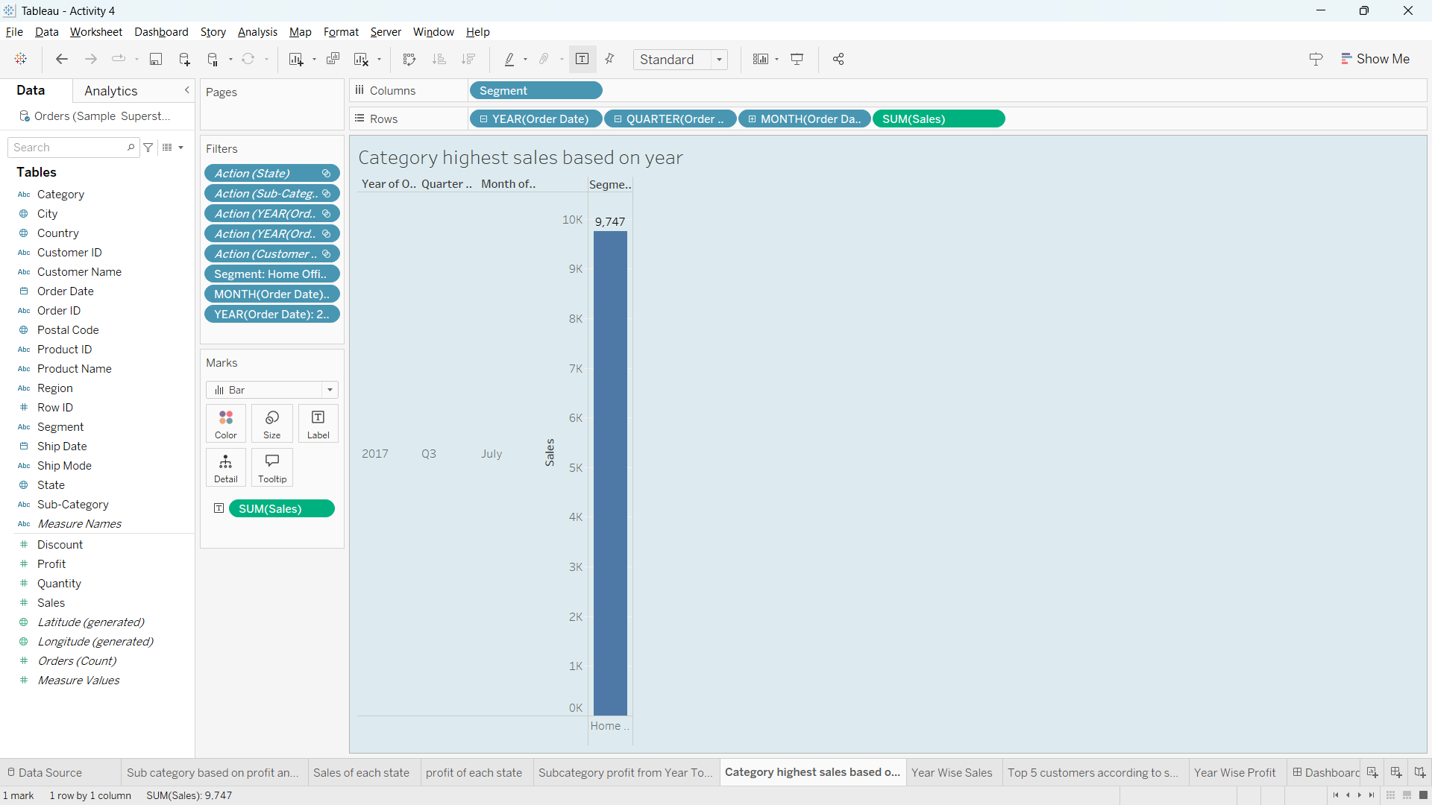

1. When was the highest sales, Profit?

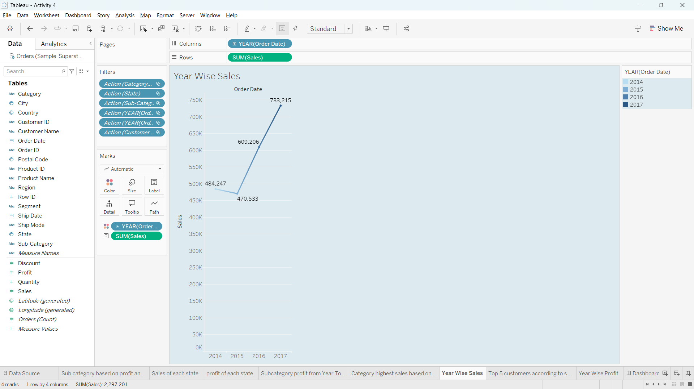

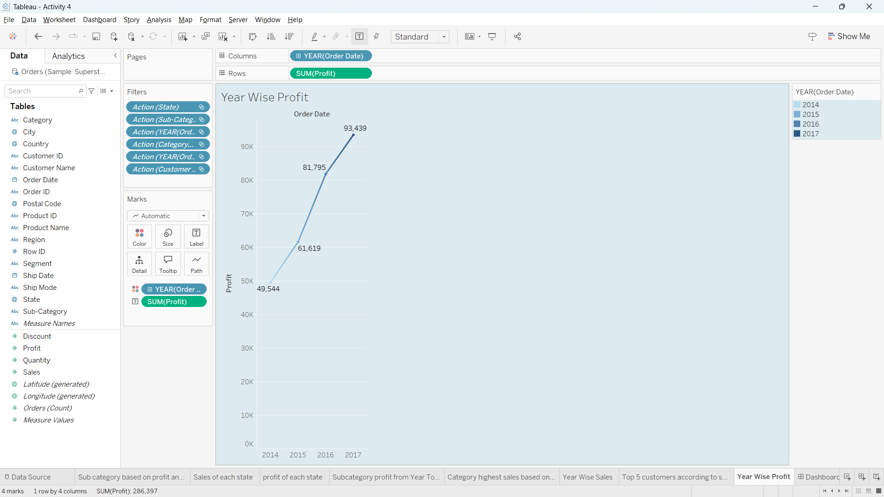

1. The top 5 customers by sales

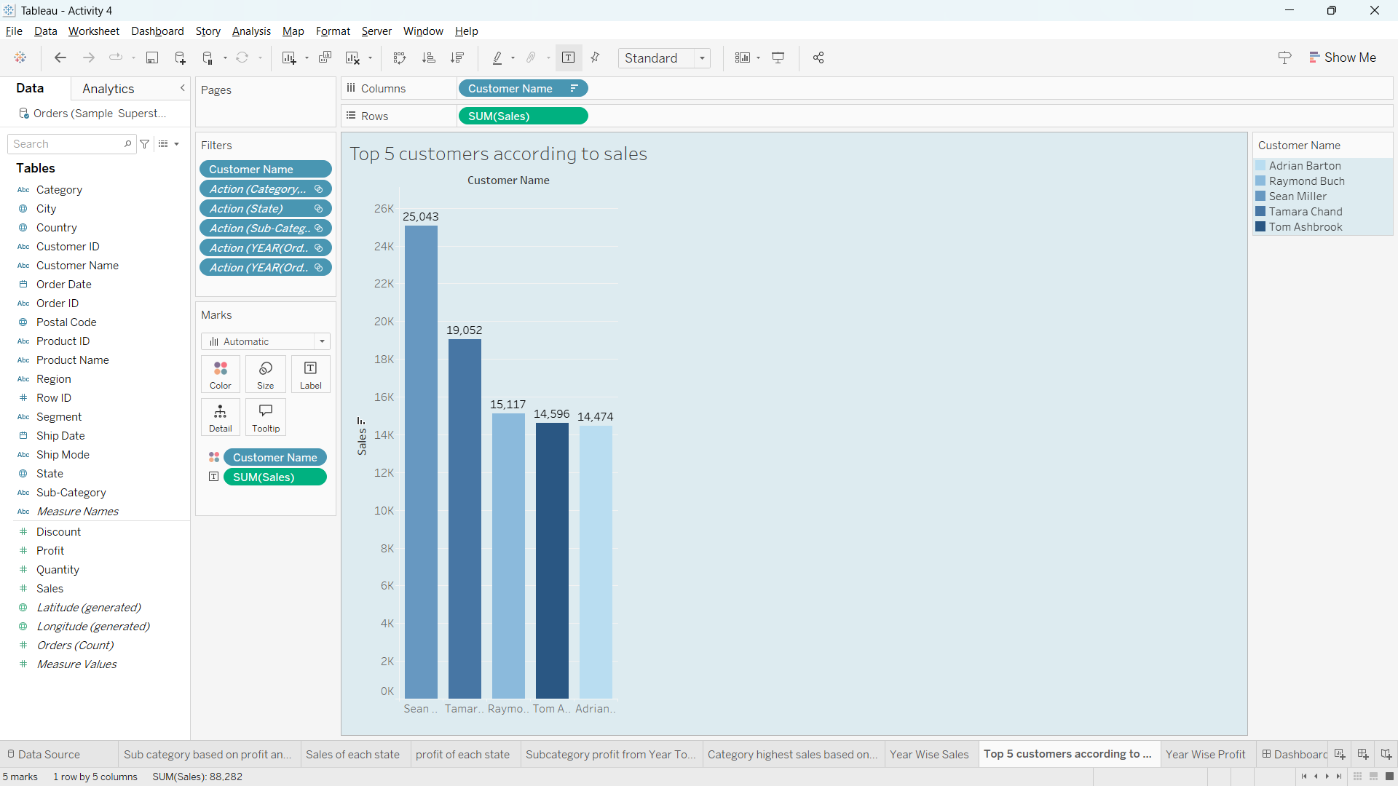

DASHBOARD:

